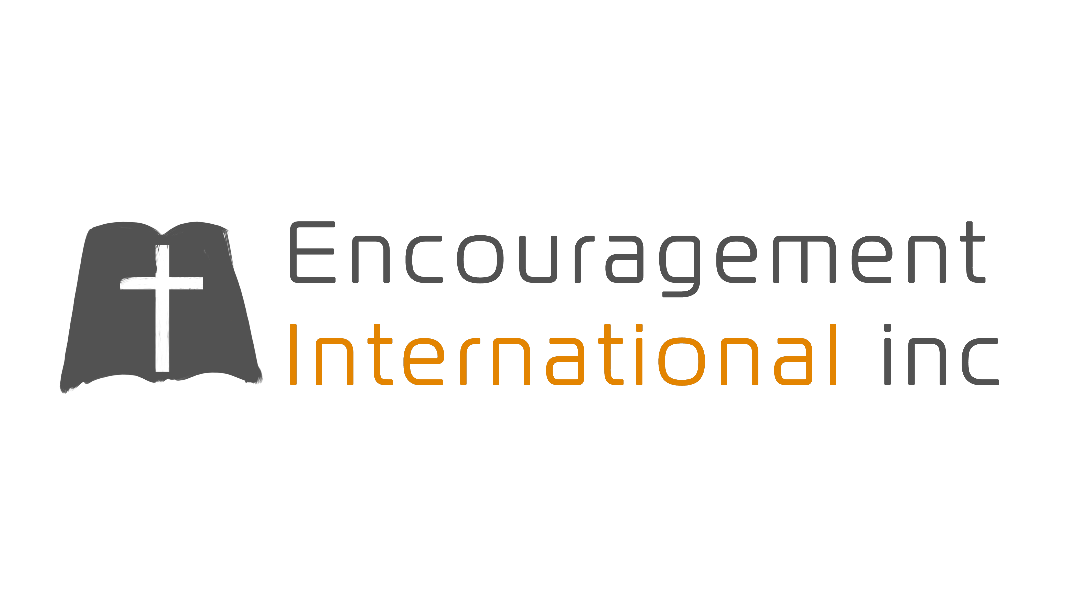
Volume No. 23 Issue No. 2 MARCH 2017

SHEPHERDS CONFERENCE
IMPORTANT UPDATES

Shepherds Conference 2018 is scheduled for March 7-9. It is never too soon to begin preparations for bringing Slavic pastors to participate in the conference. In fact, the sooner we begin the better so that they will be able to secure their visa by December 31, 2017 in order to secure the best rates for air travel in March 2018. Please prayerfully consider a designated gift now for their participation

Thank you for your generous support in 2017.

I am rejoicing in God’s provision through you for Shepherds Conference 2017! Through His provision from you, Encouragement International, Inc (EII) was able to bring 26 Slavic pastors from 8 different European countries – Portugal (3), Belarus (13), Moldova (3), Lithuania (2), Poland (1), Italy (1), Germany (1) and Ukraine (2). They arrived ‘spiritually’ fatigued from ministry and departed refreshed from the teaching of God’s Word as well as enjoying fellowship with other like-minded Russian speakers and their American counterparts. Not only did God provide the necessary financial resources through you [$10,000 in registration scholarships and about $18,000 for travel expenses] but He motivated an army of volunteers to care for the needs of these 26 Slavic pastors. A special thank you to the 7 American housing hosts and 6 drivers who made airport pickups, drop-offs and daily shuttles between host homes and the conference. Although there were 26 men who were able to come, there were 7 pastors who desperately desired to attend but were denied visas at the American Embassy and were unable to make it this year. These men will be first on the list for next year’s conference.
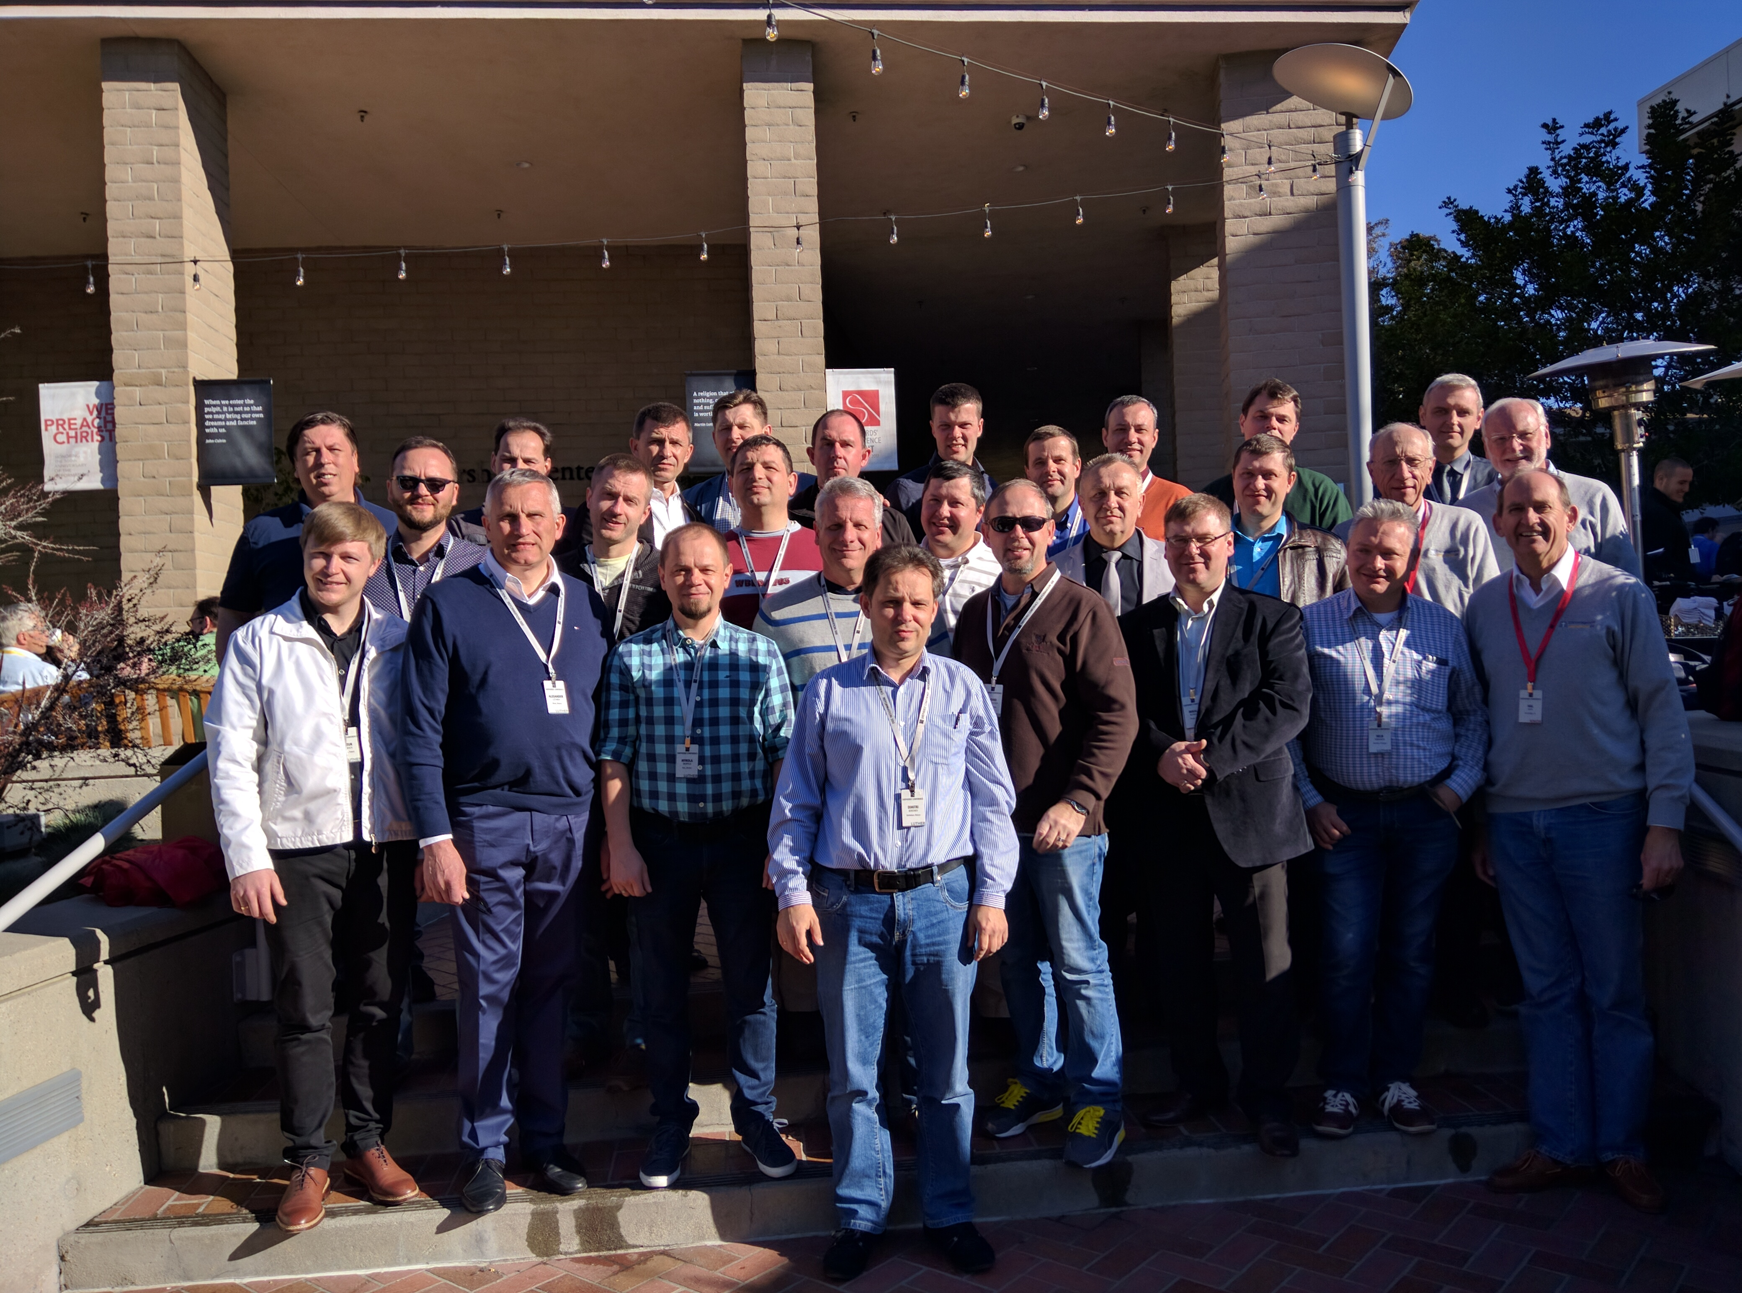

HLEB YERMAKOU UPDATE
Please be praying for Hleb, EII’s Director of Translators, as he ministers to the Russian speakers in Albufiera, Portugal and especially for his financial needs. He and his family need $3,000/month to live but he has a current support level of only $2,000/month.

FOR YOUR PRAYERFUL CONSIDERATION

Thank you for your continued financial and prayer support. We do not take the Lord’s provision through you for granted! Please prayerfully consider partnering with EII in 2017 for the following:
- $6,000 (monthly) for EII’s ongoing administrative costs (this is always a challenge).
- $7,500 for our May trip to Belarus, France and Portugal for ministry among the Russian speaking church.
- If you are led to give toward our needs, you may send your tax-deductible contribution to:
  - Encouragement International, Inc. PO Box 8524 Northridge, CA 91327
  - Through PayPal at: www.encouragementintl.com
  - Through purchases using Amazon Smile.

We love hearing from you! Do you have questions regarding our reporting of events on the field? Never hesitate to contact us by phone (818-772-1177) or email (encouragementinternational@gmail.com).
Soli Deo Gloria
Hal

