encouragement
International, inc.
Volume No. 11 Issue No. 1 January 2016

MINSK, PORTO, LISBON, CHISINAU, PARIS
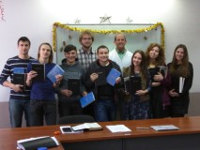
MINSK
Our trip began in Minsk, Belarus. The highlights were:
- Teaching a course on Eastern and Russian Orthodox Church History and Theology comparing what the Bible teaches about justification, grace and faith vs. the Eastern Orthodox concept.
- Providing the students with Study Bibles, commentaries, Bible Dictionaries and Atlases
- Preaching at Resurrection Church pastored by Sergei Drozd. In the morning service I taught on Church Unity from John 17:20-23. In the evening service, I taught on Marriage and the Family and then afterward Cecilie and I fielded questions on the topic.
- Doing a mid-week conference on Eastern and Russian Orthodox Church History and Theology in Borisov.
PORTO
Our next stop was Porto, Portugal to continue our study of the Attributes of God. We conducted an all Saturday conference beginning at 9:00AM and not stopping until 5:00PM. We examined the Attributes of Spirituality, Invisibility, and Eternality. After the church service on Sunday we continued the study by discussing Immutability. The women were especially thankful that Cecilie accompanied me on this trip and asked her many questions during the breaks.
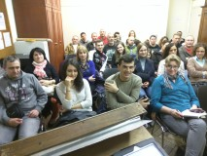
LISBON
In Lisbon we are also studying the Attributes of God and continued by teaching Invisibility, Eternality and Immutability. Many of the women expressed that the teaching was very intellectual and wanted to know how to communicate these truths about God to children. This is where it was helpful to have Cecilie along because she gave some very practical suggestions based on her mothering experience in our home.
CHISINAU
This was my first visit to Moldova in 7 years. Iura Antoci, EII’s part-time translator from Moldova, has been to the Shepherds Conference twice. When we worked together last October, I asked him how EII could serve his ministry in Moldova. He answered, “Come and do a pastors conference in January!”
Twenty pastors attended the conference and were housed in a building operated by the Bible League of Moldova. I taught on the Five Solas of the Reformation. The conference was a huge success. The evaluations from the men were:
- The messages on The Five Solas ‘stretched’ us!
- One of the men said, “I have never heard 80% of what you taught at this conference but it was extremely profitable in my understanding of Scripture. I plan to dig into my Bible and become a better student.”
- Another pastor said he was now planning to do a series on the The Five Solas with his church.
- A MacArthur Study Bible was given away to the person who could list the most names for Jesus given in the Scripture. The winning team found 25 of the 200 names listed in Scripture.
- Iura and his team of three assistances served the men by making, packaging and delivering gifts to each of the men during the sessions. The first gift was a pair of slippers for wearing around the Bible League facility with a hand-stitched tag saying ‘Sola Scriptura’. Other gifts included a candle to remind them they are lights to the world, an hour glass to remind them to master their time since the days are short. The final gift was a towel to remind them that Jesus wiped the feet of His disciples in service to them. All of us were humbled by Iura’s planning and the work of his team.
I had the opportunity to preach on two occasions … first, Sunday morning in Iura’s church on the topic of Soli Deo Gloria, and second, in the town of Yermacil at the church of a pastor who attended the conference. During the drive to this church I had a strong impression to teach John 17:20-23. Afterward Iura said that it was exactly the message this church needed to hear because dissension was ‘brewing’ disunity. This was confirmed by the comments from the congregation.
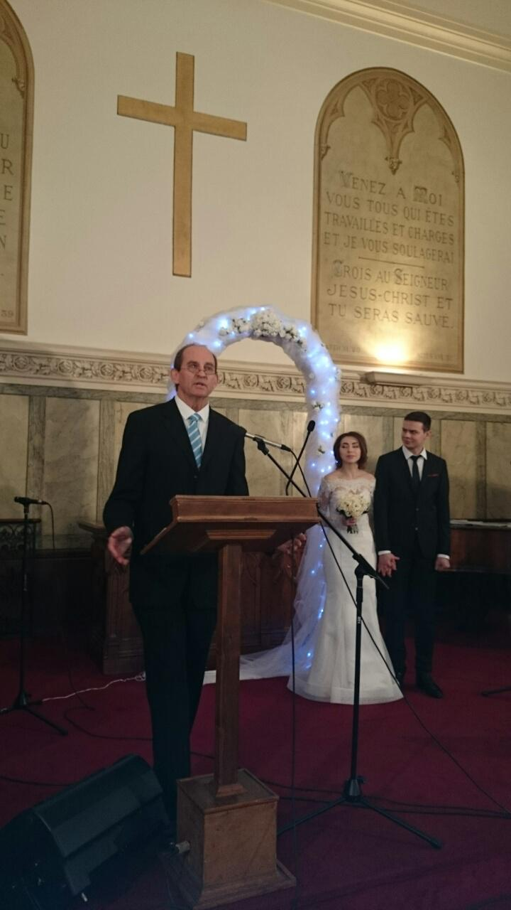
PARIS
Our final stop was to the Russian speaking Church of The Living in Paris where I was asked to do the series on the Church. I did messages on: The Definition of the Church, Church Membership, John 17:20-23 and The ‘One Anothers’ of Scripture. The conference was very well received.

Before the first session, Pastor Anatoly asked me to assist him in a wedding ceremony that would take place during the church service on Sunday. Although reluctant at first, I had the opportunity to vet the couple before Sunday. Pastor Anatoly had spoken to their pastors in Ukraine who confirmed their heart for the Gospel and pursuit of the Lord. I have performed dozens of weddings over the past 30 years but this was the first time this American performed a ceremony for two Ukrainians (Andrei and Yulia) at a church in Paris! I had the honor of preaching the ‘long’ sermon from Ephesians 5:17-33.
SULLIVAN UPDATE
Pat had the first knee replacement operation the day before Thanksgiving. The surgery went well and the second surgery took place on February 1. He is now recovering. Please pray for a very speedy recovery. We are planning to resume our travels together in May.

HLEB UPDATE Hleb and his family are safely in Portugal and his ministry is beginning to thrive.

FOR YOUR PRAYERFUL CONSIDERATION
Thank you for your continued financial and prayer support. We do not take the Lord’s provision through you for granted! Please prayerfully consider partnering with me in 2016 for the following:
- $6,000 (monthly) for EII’s (monthly) ongoing administrative costs (this is always a challenge).
- $16,500 for the May, July and October ministry trips to the Russian speaking churches of Europe.
- $11,000 ($9,000 already provided) to bring 20 pastors to the Shepherd’s Conference in March. Now is the time to book the least expensive flights and to allow the pastors to get their visas to the USA. The pastors really benefit from this conference. One pastoral team went back to their church in 2015 and hosted their own conference on Inerrancy, the topic of the last Shepherds Conference.
If you are led to give toward our needs, you may send your tax-deductible contribution to:
Encouragement International, Inc. PO Box 8524 Northridge, CA 91327 Or,
through PayPal at: www.encouragementintl.com, Or, through Amazon Smile.

Soli Deo Gloria
Hal

